1. Histogram for all variables in a dataset mtcars. Write a program to create histograms for all columns.

library(grid)

library(gridExtra)

library(ggplot2)

mtcars

cylplot<-ggplot(mtcars,aes(cyl,fill=mpg))+geom_histogram()

dspplot<-ggplot(mtcars,aes(disp,fill=mpg))+geom_histogram()

hpplot<-ggplot(mtcars,aes(hp,fill=mpg))+geom_histogram()

wtplot<-ggplot(mtcars,aes(wt,fill=mpg))+geom_histogram()

gearplot<-ggplot(mtcars,aes(gear,fill=mpg))+geom_histogram()

grid.arrange(cylplot,dspplot,hpplot,wtplot,gearplot,top = "Fig 1")

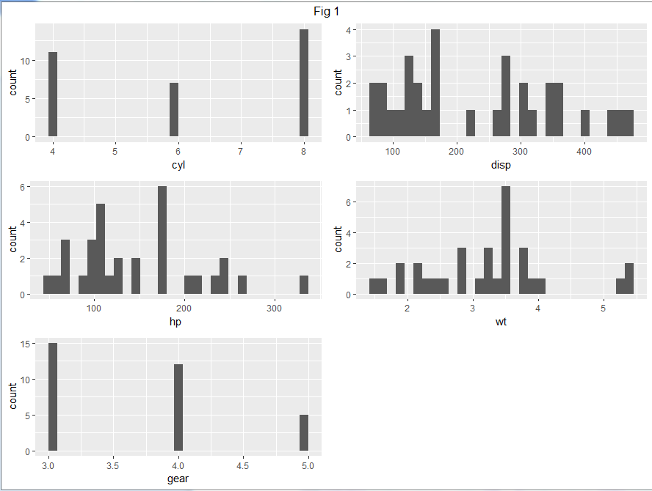

And also we can perform as below

hist(mtcars$mpg, breaks = 'FD', col = 'blue', xlab = 'MPG', main = 'MPG of mtcars Dataset')

hist(mtcars$cyl, breaks = 'FD', col = 'blue', xlab = 'CYL', main = 'CYL of mtcars Dataset')

hist(mtcars$disp, breaks = 'FD', col = 'blue', xlab = 'DISP', main = 'DISP of mtcars Dataset')

hist(mtcars$hp, breaks = 'FD', col = 'blue', xlab = 'hp', main = 'HP of mtcars Dataset')

hist(mtcars$wt, breaks = 'FD', col = 'blue', xlab = 'wt', main = 'WT of mtcars Dataset')

hist(mtcars$gear, breaks = 'FD', col = 'blue', xlab = 'gear', main = 'GEAR of mtcars Dataset')

1. Check the probability distribution of all variables in mtcars

Types of Distributions

1. Bernoulli Distribution
2. Uniform Distribution
3. Binomial Distribution
4. Normal Distribution
5. Poisson Distribution
6. Exponential Distribution
7. Write a program to create boxplot for all variables.

ggplot(mtcars, aes(x=factor(am), y=mpg)) + geom_boxplot()

ggplot(mtcars, aes(x=factor(mpg), y=mpg)) + geom_boxplot()

ggplot(mtcars, aes(x=factor(cyl), y=mpg)) + geom_boxplot()

grid.arrange(amplot,mpgplot,cylplot,top="boxplot")

